**Release pipeline for deploying application using AKS**

**DB deployment - DB Agent details**

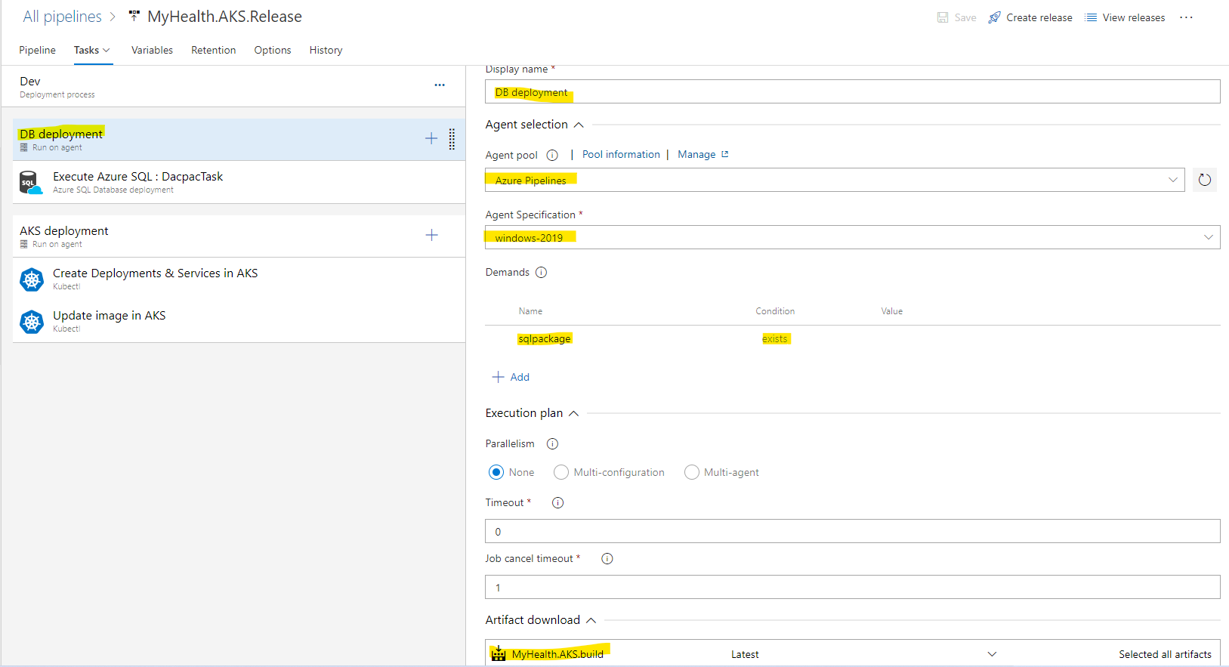

**Task-1: Execute Azure SQL**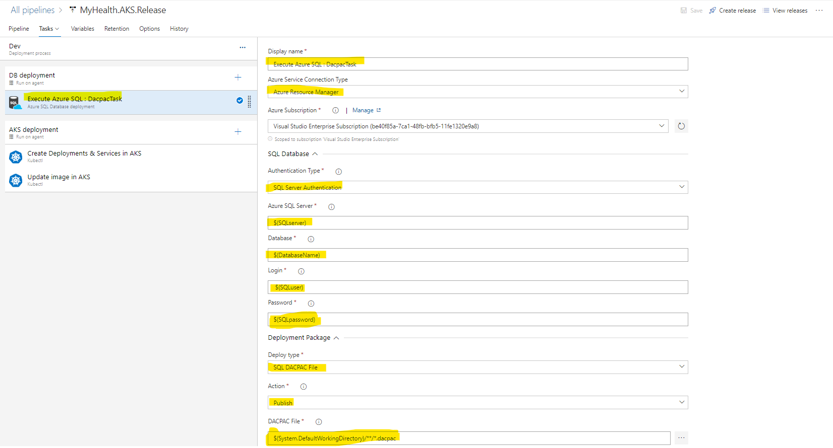

**DB deployment - DB Agent details**

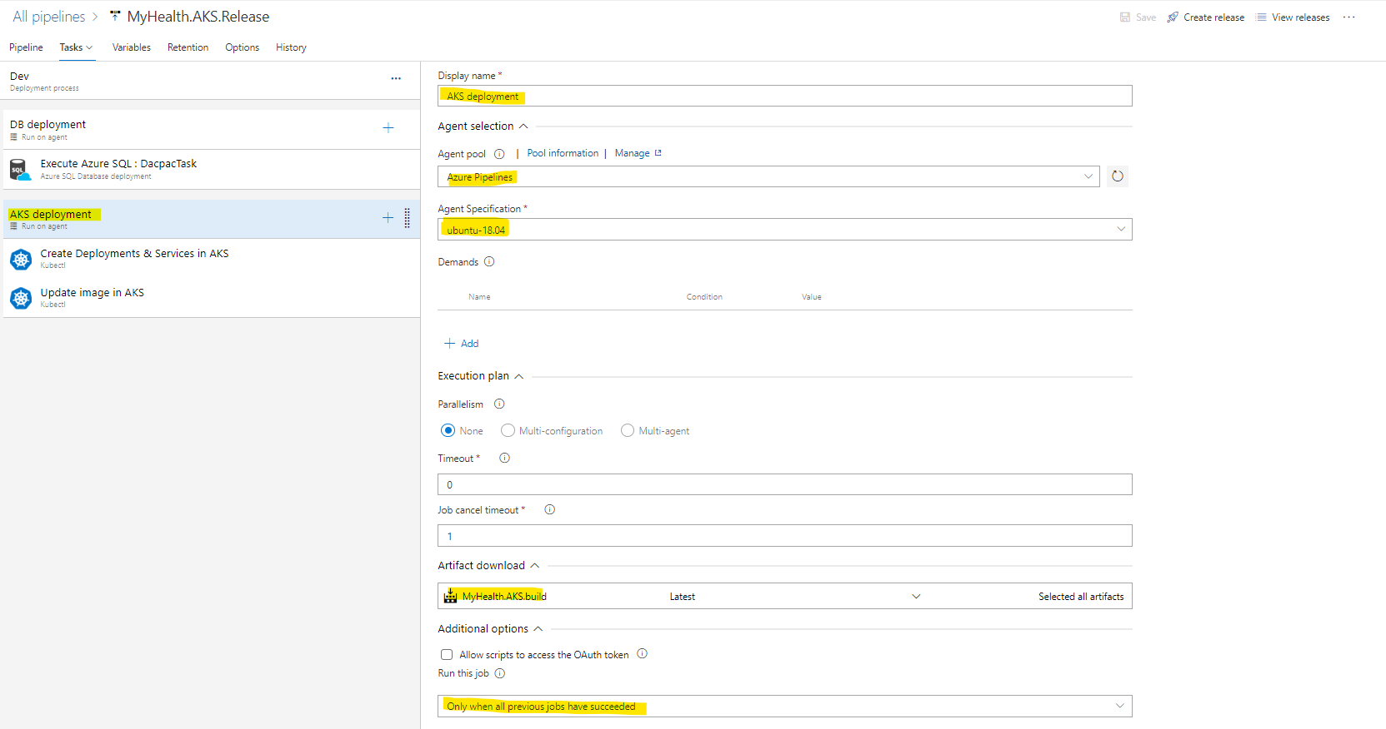

**Variables**

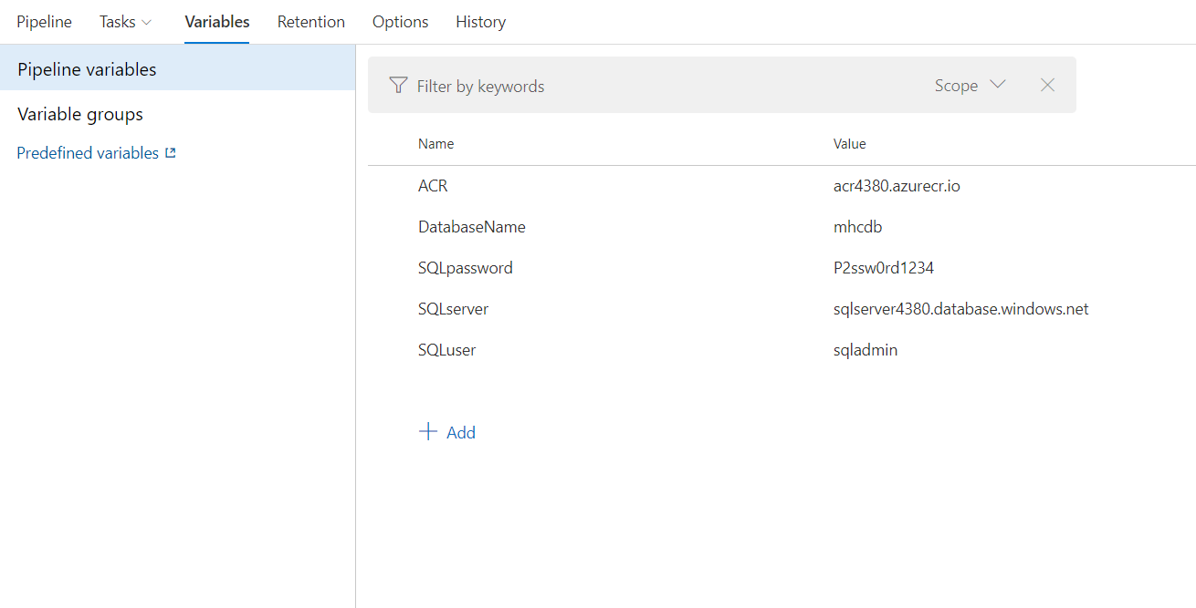

**Task-1:**

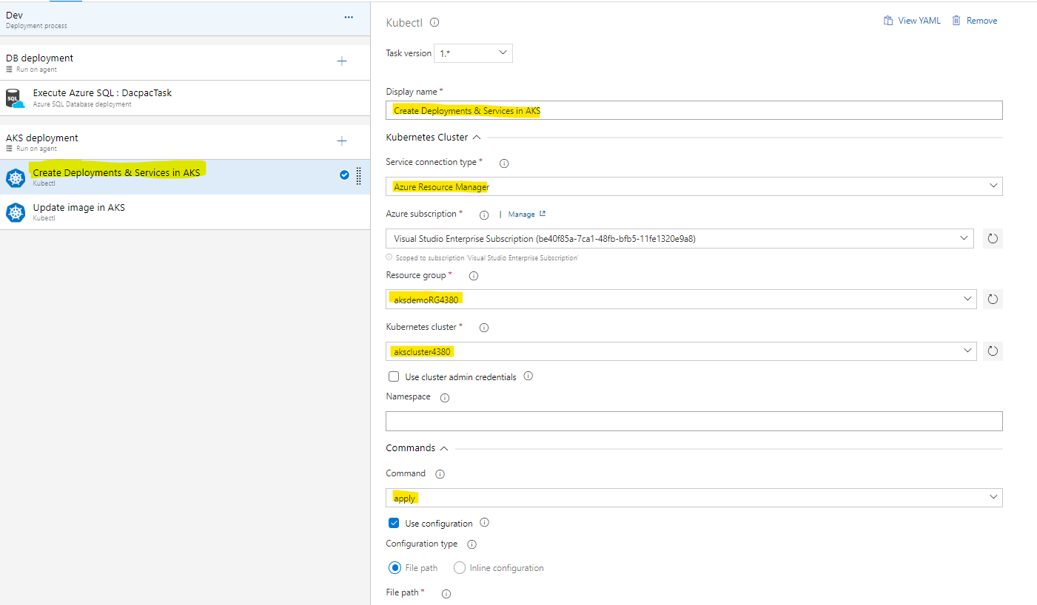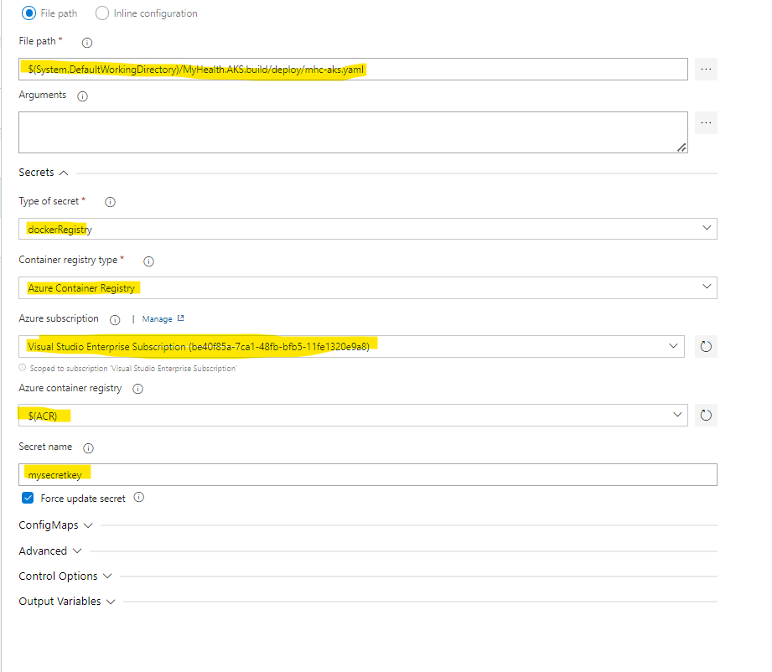

Task-2

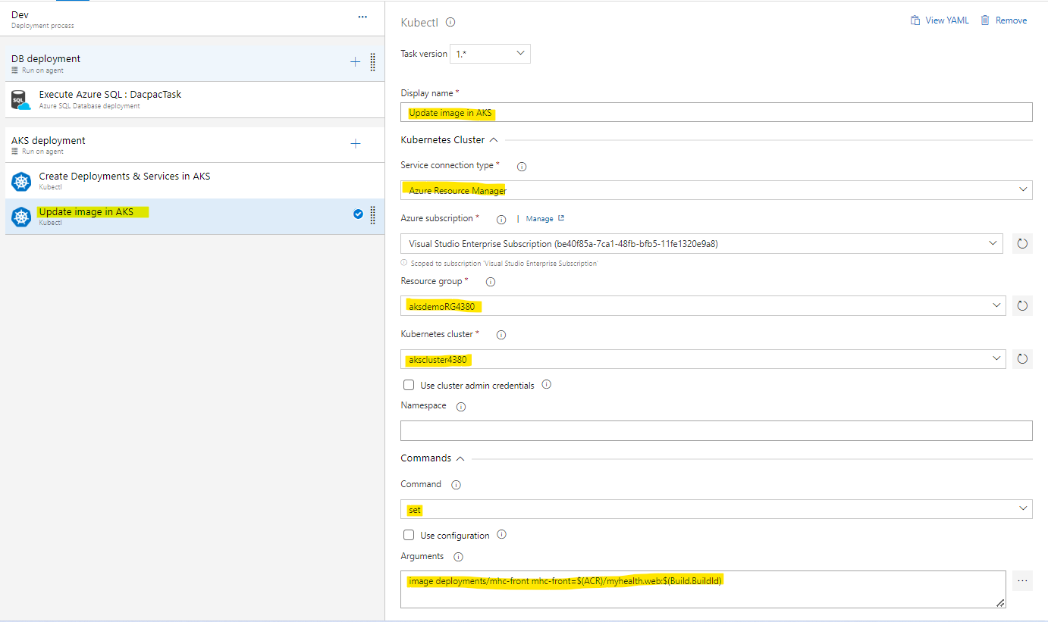

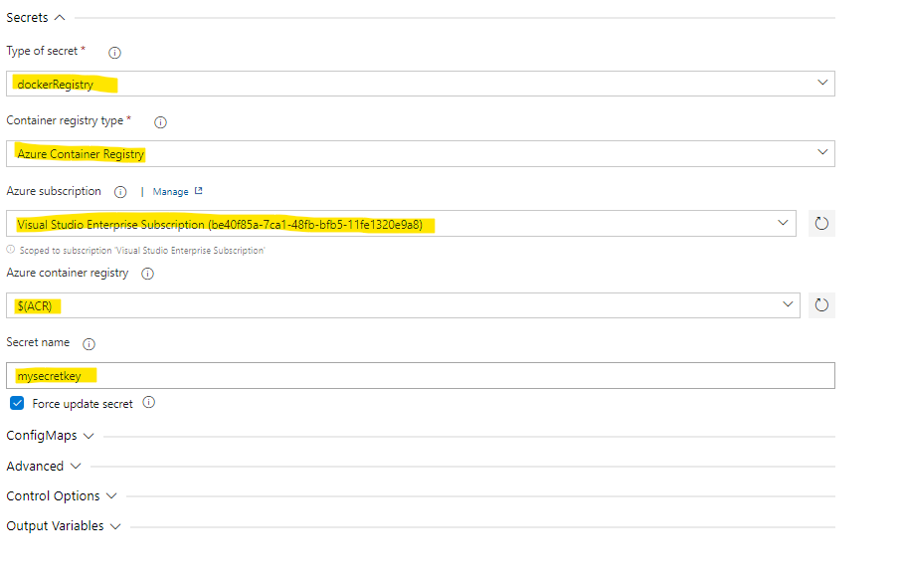

Command Arguments : image deployments/mhc-front mhc-front=$(ACR)/myhealth.web:$(Build.BuildId)